Name: _______________________________________________
Foundation Unit 12 topic test
Date:
Time: 45 minutes
Total marks available: 36
Total marks achieved: ______

Questions
Q1.
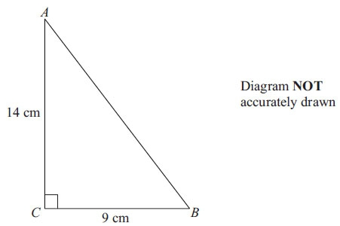
Calculate the length of AB.
Give your answer correct to 1 decimal place.

..............................................................................................................................................
(Total for Question is 3 marks)

Q2.
XYZ is a right-angled triangle.
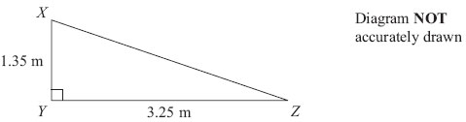
Calculate the length of XZ.
Give your answer correct to 3 significant figures.

..............................................................................................................................................
(Total for Question is 3 marks)

Q3.
Triangles ABD and BCD are right-angled triangles.
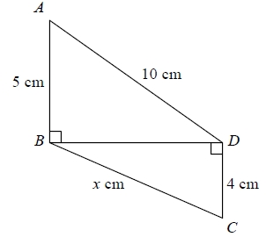
Work out the value of x.
Give your answer correct to 2 decimal places.
...........................................................
(Total for question = 4 marks)

Q4.
PQR is a right-angled triangle.
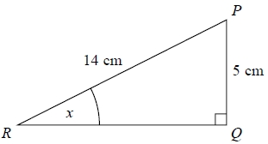
Work out the size of the angle marked x.
Give your answer correct to 1 decimal place.
...........................................................°
(Total for question = 2 marks)

Q5.
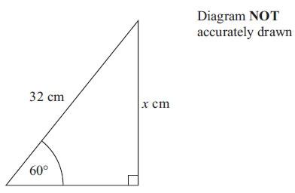
Calculate the value of x.
Give your answer correct to 3 significant figures.

..............................................................................................................................................
(Total for Question is 3 marks)

Q6.
GHJ is a right-angled triangle.
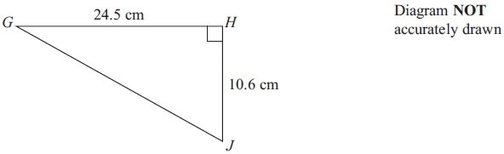
(a) Calculate the length of GJ.
Give your answer correct to one decimal place.

..............................................................................................................................................
(3)
LMN is a different right-angled triangle.
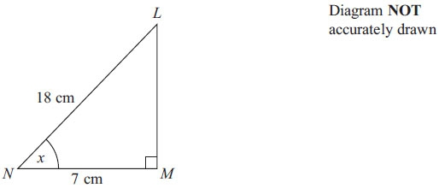
(b) Calculate the size of the angle marked x.
Give your answer correct to one decimal place.

..............................................................................................................................................
(3)
(Total for Question is 6 marks)

Q7.
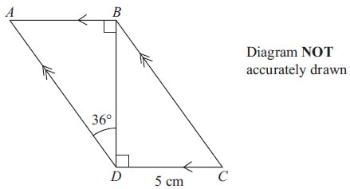
ABCD is a parallelogram.
DC = 5 cm
Angle ADB = 36°
Calculate the length of AD.
Give your answer correct to 3 significant figures.

..............................................................................................................................................
(Total for Question is 4 marks)

Q8.
The diagram shows a ladder leaning against a vertical wall.
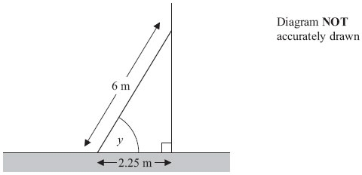
The ladder stands on horizontal ground.
The length of the ladder is 6 m.
The bottom of the ladder is 2.25 m from the bottom of the wall.
A ladder is safe to use when the angle marked y is about 75°.
Is the ladder safe to use?
You must show all your working.

(Total for Question is 3 marks)

Q9.
ABC is an isosceles triangle.
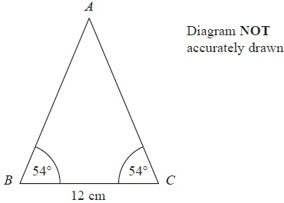
Work out the area of the triangle.
Give your answer correct to 3 significant figures.
........................................................... cm²
(Total for Question is 4 marks)

Q10.
The diagram shows the positions of a tower and a tree.
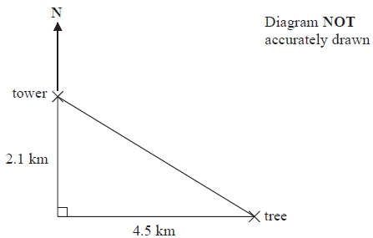
The tree is 2.1 km South of the tower and 4.5 km East of the tower.
(a) Work out the distance between the tower and the tree.
Give your answer correct to one decimal place.
...........................................................km
(3)
(b) Work out the bearing of the tree from the tower.
Give your answer correct to the nearest degree.
...........................................................°
(4)
(Total for Question is 7 marks)

Examiner's Report
Q1.
Candidates who realised that they had to use Pythagoras' theorem generally went on to give a fully correct method and final answer. Although the question advised candidates to give their answer to 1 decimal place, they were not penalised for incorrect rounding once an accurate answer had been seen. Students need to read calculator displays with care as many gave 227 as an interim answer rather than the correct 277. Use of the ANS key on a calculator would help prevent this error although students should always be encouraged to also write down full working. Occasionally candidates multiplied the side lengths 9 × 14 and, despite the diagram not accurately drawn warning, many had clearly measured the hypotenuse length to give 7.3 or 7.2 cm.

Q2.
Few candidates were able to score full marks on this question, though many were able to score at least one mark for 1.35² + 3.25². A significant number of candidates did not square and add the lengths of the sides but doubled and squared them.
Some candidates, having used the correct process to work out 12.385, rounded this to 12.4 before taking the square root.
Candidates should be advised to use all the figures on their calculator display rather than an approximation of these figures. A very common incorrect method here was to multiply the lengths of the sides, usually to work out the area of the triangle.

Q3.
No Examiner's Report available for this question

Q4.
No Examiner's Report available for this question

Q5.
On the whole, candidates either scored full marks or no marks in this question. A few candidates were unable to recognise the correct trigonometric function even having written SOHCAHTOA, others were able to start with a correct trigonometric statement and then made errors when rearranging their initial statement but most who got this far went onto obtain full marks. It was evident that some candidates had their calculator in the wrong angle mode. It was surprising the number of candidates who confused lengths and angles in their calculations. Some candidates seemed to take a lucky guess that the adjacent side was half of 32 with no evidence of the use of cos 60 and were then able to use Pythagoras to find x correctly.

Q6.
The standard Pythagoras question in part (a) was well answered by most candidates. Errors were sometimes made in the calculations and some candidates who tried to apply Pythagoras could not do so correctly.
Part (b) was answered less well. Most of the candidates who correctly identified cos x =⁷⁄₁₈ went on to give the correct answer but some lost the final accuracy mark by rounding prematurely. Some candidates worked out the correct answer by finding the length of LM using Pythagoras and then using either the sine rule or cosine rule to find the angle marked x, but many who started this method were unsuccessful. A small number used sine instead of cosine to obtain an incorrect answer of 22.9°.

Q7.
Most candidates scored either 1 mark (for AB = 5 cm), or full marks for finding the length of AD correctly. It was very common to see the sine rule being used in the right angled triangle ABD, sometimes involving the right angle and sometimes the 54°. A few candidates used tan and Pythagoras in triangle ABD. Providing all the steps involved were logically correct, they were awarded the two method marks. Often this approach led to an answer outside the acceptable range, due to accumulation of rounding errors.

Q8.
Many correctly identified Cosine as the method of solution, found the angle and wrote an appropriate statement to go with it. Some candidates however tried Pythagoras with either the Sine or Cosine Rule with varying degrees of success.

Q9.This was the first question on the paper that was poorly attempted. The preferred route taken by candidates was to find either AB or AC, which was nearly always correctly done. Most of these candidates then went on to substitute their values into ½abSinC with just a few using the wrong value for the included angle. A few candidates, having found the slant height, used it as the perpendicular height of the triangle when calculating the area using ½ b×h, resulting in the loss of marks. It was rare to see the triangle split into two right angled triangles and tan54 used to find the height, though those who chose this route usually did it well.

Q10.
Part (a) was usually correctly answered well with students showing a sound understanding of Pythagoras. A few did try to find an angle first and then work out the distance from the tree to the tower. In part (b), many students were able to correctly find the size of one of the angles but the understanding of bearings was poor. Some students insisted on finding an angle using either, or in some cases both, the sine or cosine rules. Often this lead to inaccuracies, as a result of premature approximations. A significant number of students simply measured the angle with a protractor ignoring the fact that the diagram was not drawn to scale.

Mark Scheme
Q1.
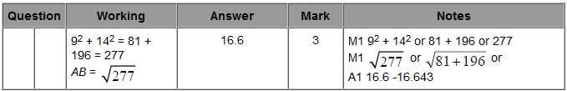

Q2.
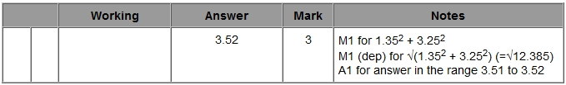

Q3.
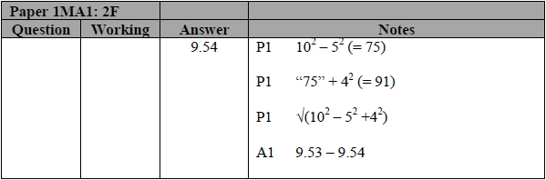

Q4.
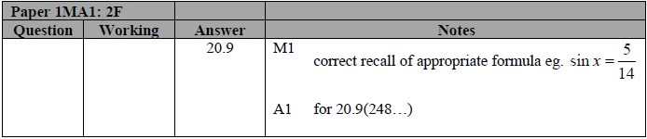

Q5.
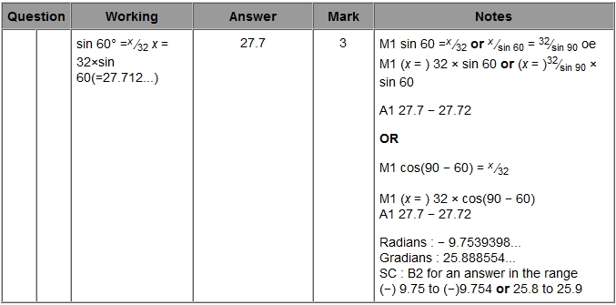

Q6.
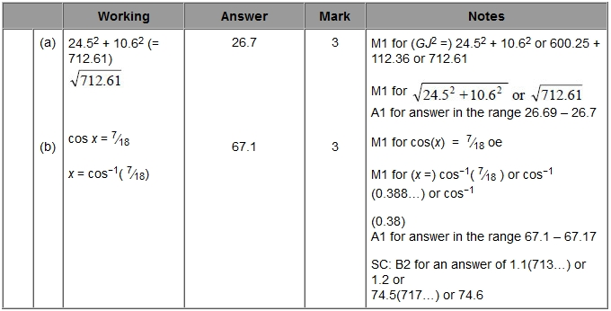

Q7.
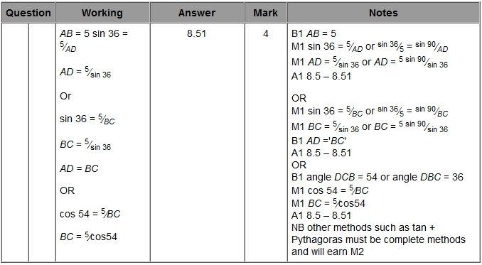

Q8.
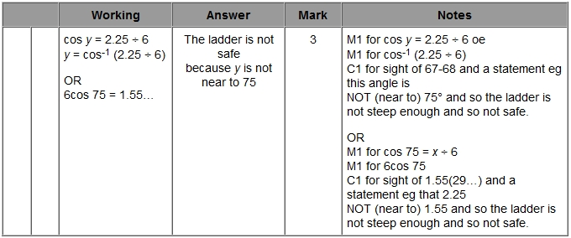

Q9.
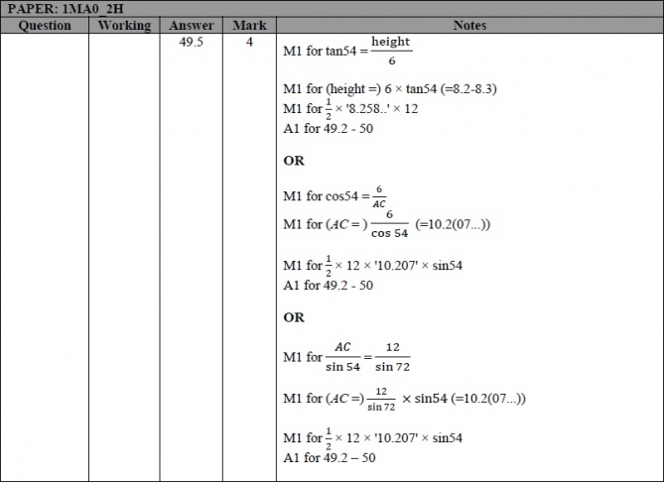

Q10.
